Only Vmware:

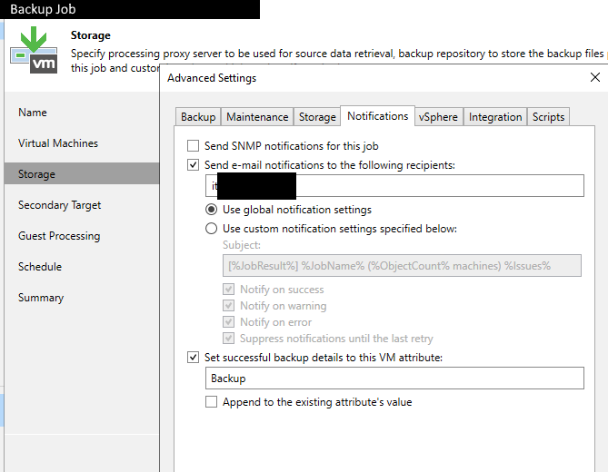

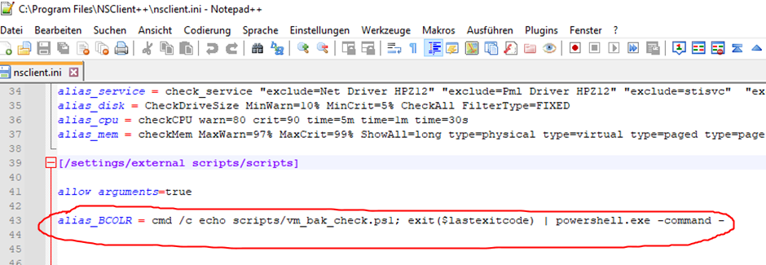

alias_BCOLR = cmd /c echo scripts/vm_bak_check.ps1; exit($lastexitcode) | powershell.exe -command -

